**TOURISM MANAGEMENT SYSTEM**

**Team Members:**

1. **Sunrit Sarkar- 19BCE1679**
2. **Shourya Gupta- 19BCE1704**
3. **Sam Methuselah- 19BCE1698**

**Course Code: CSE2004**

**Course Title: Database Management Systems**

**Class Number: CH2019205000734**

**Course Faculty: Dr. L.M. Jenila Livingston**

**Abstract**

The importance of information and efficient information management is steadily increasing due to the evolution of new technologies and high-capacity storage media but also because growing market dynamics raise information needs. A marketing decision support system (MDSS) can be of particular importance as it supports organizations in collecting, storing, processing, and disseminating information, and in the decision-making process by providing forecasts and decision models. The recent past showed a greater interest in recommender techniques. Nowadays there are many travel packages existing from different websites to almost all the places over the world. A customer finds it very difficult to search for the best package as he/she has to browse multiple websites, contact many travel agents and etc. which is a tedious process and is time consuming. There should be a system where the user should have the best package on the Internet and with a single click book the hotels, travelling and food arrangements. To address this issue, we adopt Travel Package System which offers the best package among all the other packages that are on the web. This project will help tourist to by default select the best Travel Package among all the package deals on the web. The customer will select a travel package for a particular place based on the recommendations provided by the previous customers who had experience with the package.

**Introduction**

**Tourism management system**: This is an online project developed using Php and MySQL.. The purpose of this project is to provide the complete information about the packages available for a tour. There are 2 different types of users. First the customer visits the site and enters the place he/she wishes to travel. Then he sends the details to the travel and tourism agency. The employee of travel and tourism agency receives the mail and checks which vehicle is available for that day physically by contacting the travel agents and reverts back to the customer along with the quotation. If the customer agrees for any one of the quotation, he can reply back along with agreed quotation. Then the agency will take down all the details of the customer and will send a confirmation message to the customer.

This software is user friendly and helps in finding the vehicle sooner rather than wandering manually everywhere to find for vehicles. After the tour the customer can come back to the site and enter his feedback about the travel and tourism agency.

This project development a website for Tour & Travel management system with HTML-5,CSS 3,PHP as front-end & MYSQL EXPRESS as back-end. Tour & Travel management system planning the tour for their customer. It is an application which decreases few efforts of planning of trip or making of yours holidays happy.

**Project Objective**

Tourism Management System is an integrated software developed for tour operating companies. The main aim of this project is to help the tourism companies to manage their customers, vehicles, and agent. It makes all operation of the tour company easy and accurate. The standalone platform makes tourism management easy by handing agencies requests and providing servers for the customers located at different parts of the various cities. Different modules have been incorporated in this project to handle different parts and sector of the tour management field.

Objectives:

* The Tourism Management System is a web based application and maintains a centralized repository of all related information.
* The Objective of this project is to develop a system that automates the process and activities a travel agency and customer details.
* The purpose is to design a system using which one can perform all operations related to travelling and sight- seeing.
* This System will provide to connect directly Customers and Agent through internet.
* This System provide facilities to modify and delete tourist’s data as well as client data.
* This System provide feedback mechanism for tourist.
* This System provide information about the Inbound and Outbound Tour Packages.
* This System maintain & control the database of tourists’ information.
* This System display attractive tourist places.
* This System gives a variety of travel services that will sure to match all your priorities.
* This System help to make strong relationship with customers so that they can enjoy that holiday of their dreams.
* This System also helps to develop tourism with different cultures so that they enrich the tourists experience and build pride.
* This System will provide display platform in where a tourist can find their tour places according to their choices.
* This System will provide easy and efficient work for the agency.

**About Front End:**

The front end is an interface between the user and the back end. The front and back ends may be distributed amongst one or more systems.

In network computing, *front end* can refer to any hardware that optimizes or protects network traffic. It is called application front-end hardware because it is placed on the network's outward-facing front end or boundary. Network traffic passes through the front-end hardware before entering the network.

In compilers, the front end translates a computer programming source code into an intermediate representation, and the back end works with the intermediate representation to produce code in a computer output language. The back end usually optimizes to produce code that runs faster. The front-end/back-end distinction can separate the parser section that deals with source code and the back end that generates code and optimizes.

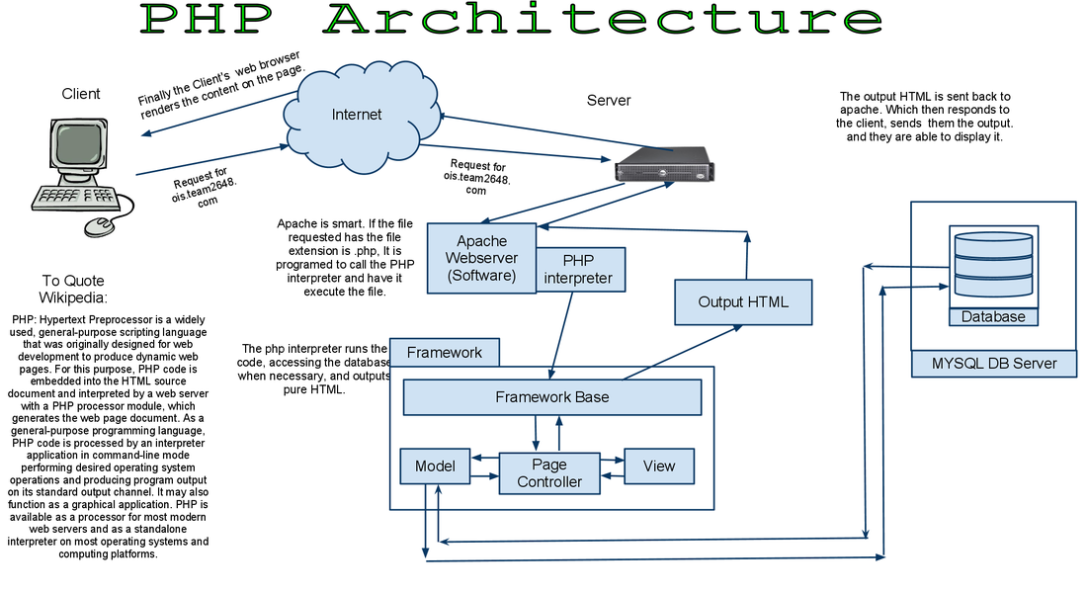

**CODING LANGUAGES USED FOR FRONT-END:**

**PHP** is now officially known as “**PHP: Hypertext Preprocessor**”. It is a server-side scripting language usually written in an HTML context. Unlike an ordinary HTML page, a PHP script is not sent directly to a client by the server; instead, it is parsed by the PHP binary or module, which is server-side installed. HTML elements in the script are left alone, but PHP code is interpreted and executed. PHP code in a script can query databases, create images, read and write files, talk to remote servers – the possibilities is endless. The output from PHP code is combined with the HTML in the script and the result sent to the user’s web-browser, therefore it can never tell the user whether the web-server uses PHP or not, because the entire browser sees is HTML.

**HTML** or **Hyper Text Markup Language** is the standard markup language used to create web pages.

**Cascading Style Sheets** (**CSS**) is a style sheet language used for describing the look and formatting of a document written in a markup language. While most often used to style web pages and user interfaces written in HTML and XHTML, the language can be applied to any kind of XML document, including plain XML, SVG and XUL. CSS is a cornerstone specification of the web and almost all web pages use CSS style sheets to describe their presentation.

**JavaScript** (**JS**) is a dynamic computer programming language. It is most commonly used as part of web browsers, whose implementations allow client-side scripts to interact with the user, control the browser, communicate asynchronously, and alter the document content that is displayed. It is also being used in server-side network programming, game development and the creation of desktop and mobile applications.

**About Back End:**

Web programmers are concerned with launching websites, updates, and maintenance, among other things. All of that work, to support the front-end of the website, is done by the back-end. The back-end has three parts to it: server, application, and database.

To better explain how all of this works, let’s use the example of a customer trying to purchase a plane ticket using a website. Everything that the customer sees on the web-page is the front-end, as we have explained before, but once that customer enters all of his or her information, such as their name, billing address, destination, etc, the web application stores the information in a database that was created previously on the server in which the website is calling for information.

The web application creates, deletes, changes, renames, etc items in the database. For example, when a customer purchases a ticket, that creates an item in the database, but when they have a change in their order or they wish to cancel, the item in the database is changed.

In short, when a customer wants to buy a ticket, the back-end operation is the web application communicating with the server to make a change in a database stored on said server. Technologies like PHP, Ruby, Python, and others are the ones back-end programmers use to make this communication work smoothly, allowing the customer to purchase his or her ticket with ease.

So, in this project we have used MySQL as the database. The required services aren’t unique to MySQL. They’re services most network-based client/server tools or servers need: connection handling, authentication, security, and so forth.

The third layer contains the storage engines. They are responsible for storing and retrieving all data stored “in” MySQL. Like the various filesystems available for GNU/Linux, each storage engine has its own benefits and drawbacks. The server communicates with them through the storage engine API. This interface hides differences between storage engines and makes them largely transparent at the query layer. The API contains a couple of dozen low-level functions that perform operations such as “begin a transaction” or “fetch the row that has this primary key.” The storage engines don’t parse SQL or communicate with each other; they simply respond to requests from the server.

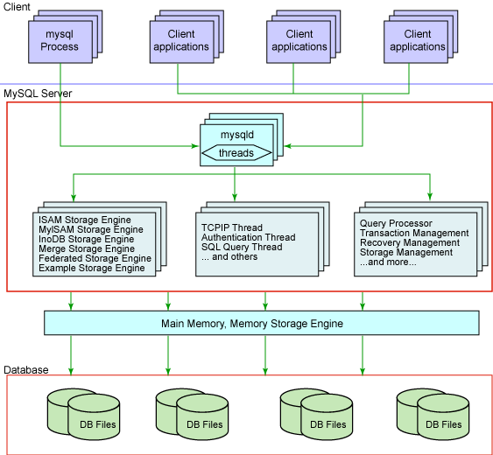

|  |
| --- |
|  |

**DATABASE DESIGN**

The Database consists of 6 tables:

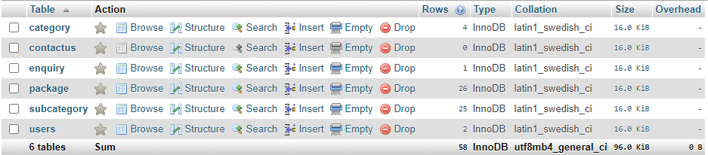**THE TABLES:**

“category” table:

“contactus” table:

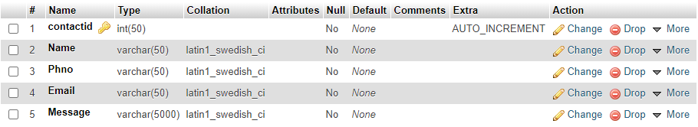

P.T.O.->

“enquiry” table:

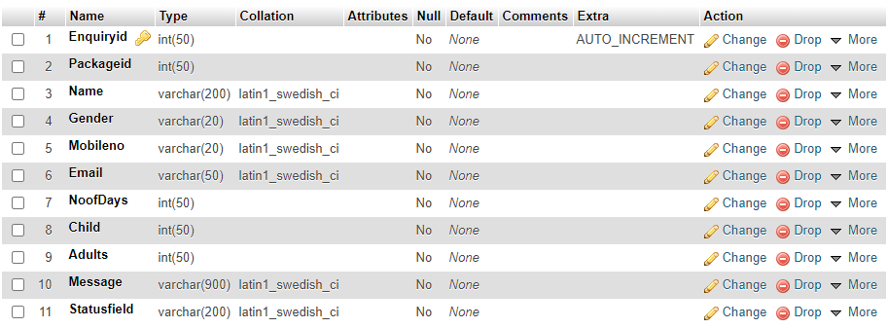“package” table:

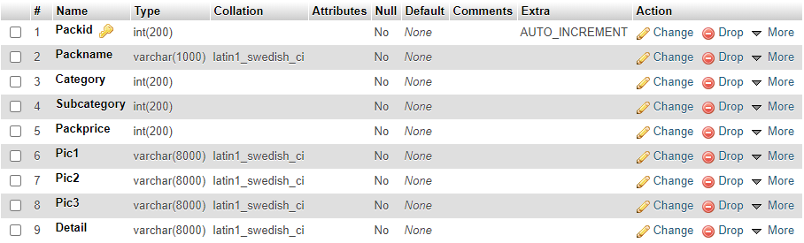“subcategory” table:

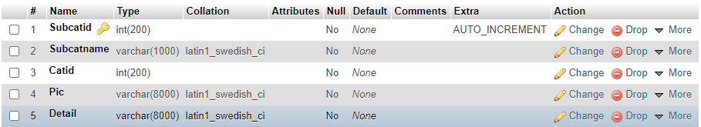

P.T.O.->

“user” table:

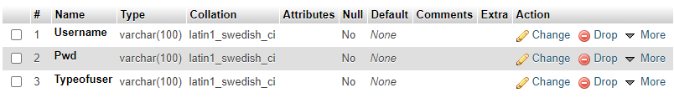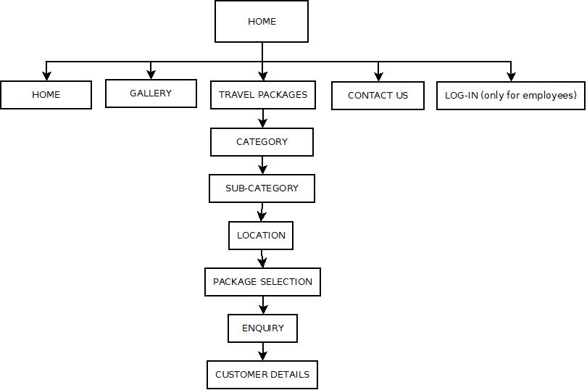**Data Flow Print:**

**P.T.O->**

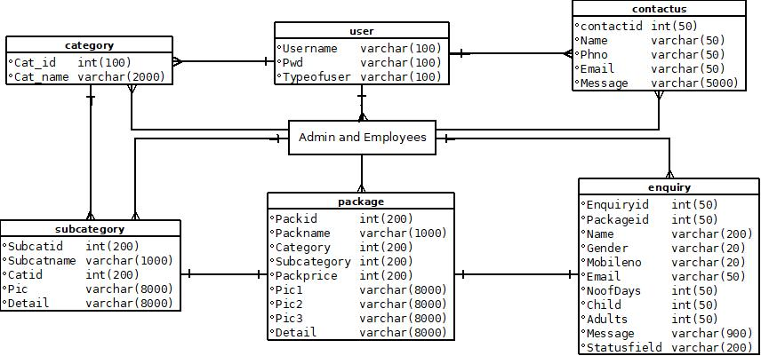**Class Diagram:**

**P.T.O->**

**ER-Diagram:**

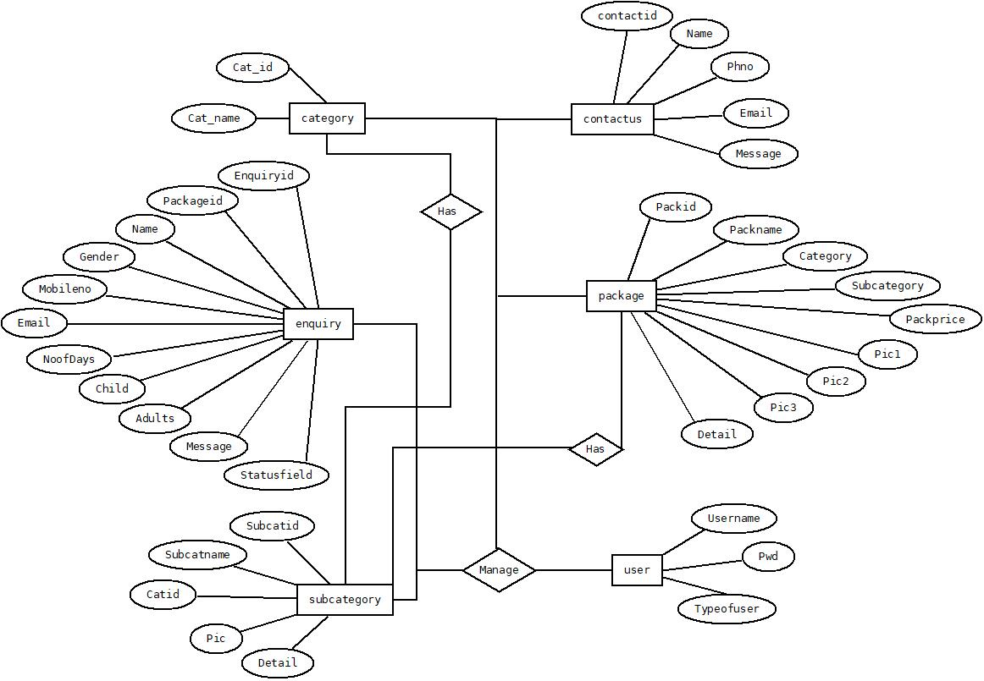

**Methodolody of Modules**

The user module:

* When a user clicks on the website, he/she is taken to the main home page where he/she can see the fabulous images from the tours we conducted.
* Along with that, he/she gets options to click onto like gallery, contact us, travel packages and login (only for employees).
* He/she when selected travel packages are lead to a variety of tour options namely:
  + Family tours
  + Religious tours
  + Adventure tours
  + Small group tours
* On choosing one of the above, they are given options to select which country.
* On selecting the country, they have to choose the city/location.
* On selecting the location, they get to know the package price and all the marvellous things the package carries.
* Now, the user can enquire about it. When he/she enquire, they are asked to fill details namely: name, gender, mobile number, email-id, number of days they wanna stay, number of children, number of adults and enquiry message if the user wants to add/ask something else.
* Once, the enquiry is saved, the admin/agent from the travel agency can access it and verify the details and confirm the deal with the user once he/she has arranged the tour.

The agent module:

* The agent/employee is the one who gets to log in.
* Once logged in, the employee gets options namely:
  + Add category-he/she can add a new category
  + View category- he/she can view the category
  + Add Subcategory- he/she can add a new subcategory
  + View Subcategory- he/she can view a subcategory
  + Add Package- he/she can add a package
  + View Package – he/she can view a package
  + View Enquiry – he/she can view enquiry and confirm the tour.

The admin module:

* Once, the admin logs in, he/she has a different interface from the agent login.
* Once logged in, the employee gets options namely:
  + Add user- he/she can only add user
  + Update user- he/she can only update the power of user
  + Delete user- he/she can remove any user
  + Add category-he/she can add a new category
  + Update category- he/she can update a category
  + Delete category- he/she can delete a category
  + View category- he/she can view the category
  + Add Subcategory- he/she can add a new subcategory
  + Update Subcategory- he/she can update a subcategory
  + Delete Subcategory- he/she can delete a subcategory
  + View Subcategory- he/she can view a subcategory
  + Add Package- he/she can add a package
  + Update Package- he/she can update a package
  + Delete Package- he/she can delete a package
  + View Package – he/she can view a package
  + View Enquiry – he/she can view enquiry and confirm the tour.

**Minimum Hardware and Software Specifications:**

**Hardware Requirement**

Processor : Intel Core Duo 2.0 GHz or more

RAM : 1 GB or More

Hard-disk : 80GB or more

Monitor : 15” CRT, or LCD monitor

Keyboard : Normal or Multimedia

Mouse : Compatible mouse

**Software Requirement**

Front End : XAMPP Server Or WAMP Server

Back End : MySQL Server

Operation System : Windows XP with service pack ver.2 or Windows 7,8,10

**Conclusion**

Tourism is currently recognized as a global industry which is growing at a high rate like other industry. There are many different activities are occurred in tour activities. Our ‘Tour Management’ web based application helps in online distribution of tour packages. This ‘Tour Management System’ can be fully customized with integration different API’s. It has friendly environment that connects customer willingly. Finally, I can say that this Web Based Application will help tour manager to control and handle the tour related activates effectively and efficiently.

**Screenshots:**

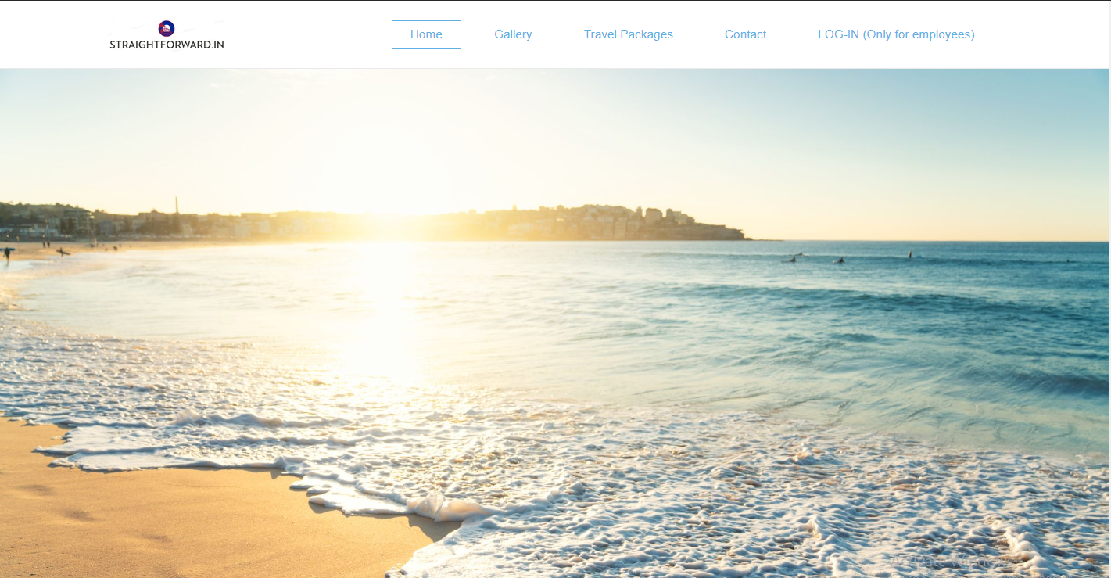

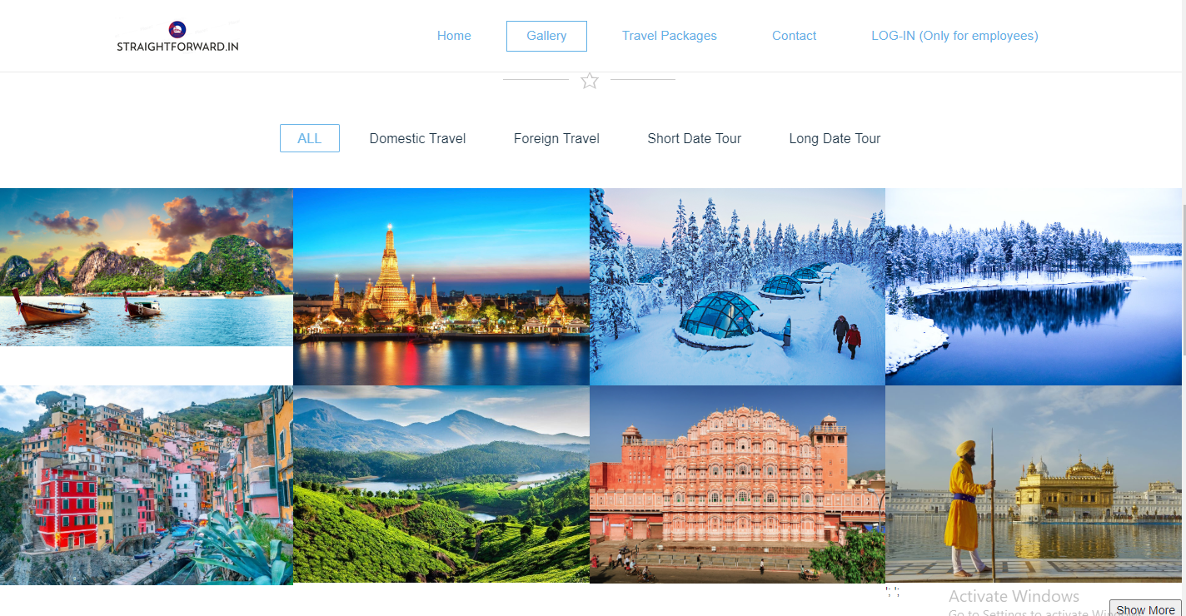

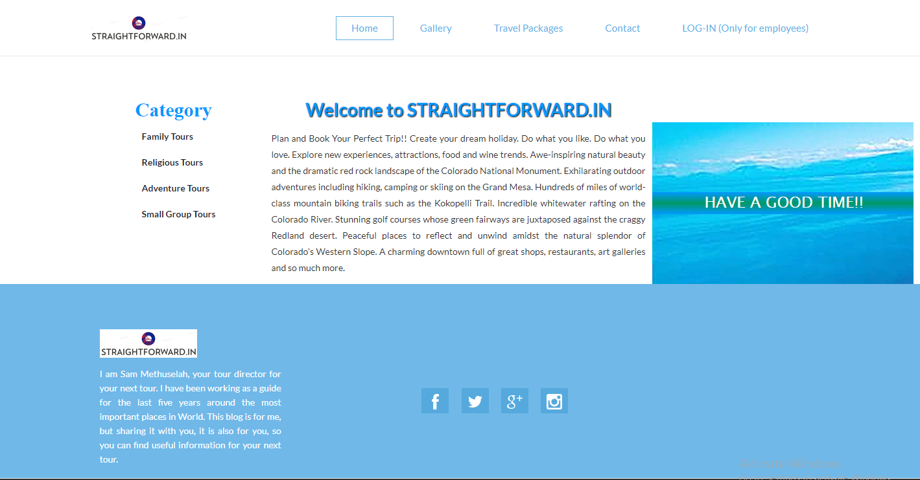

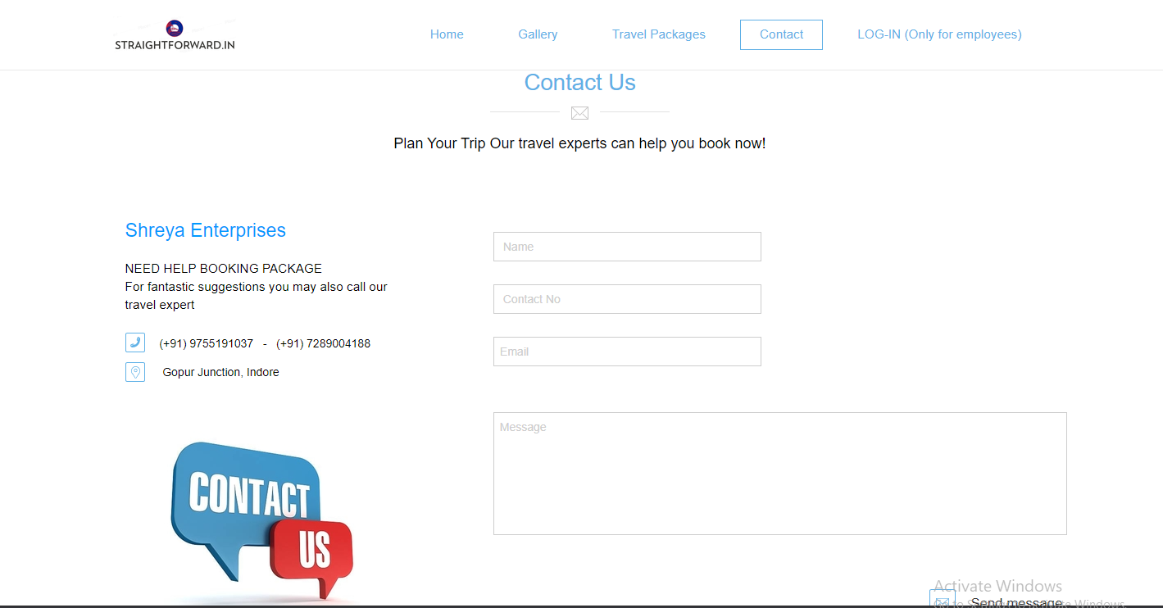

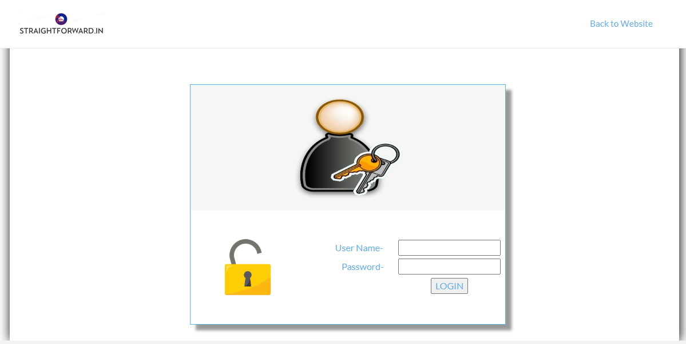

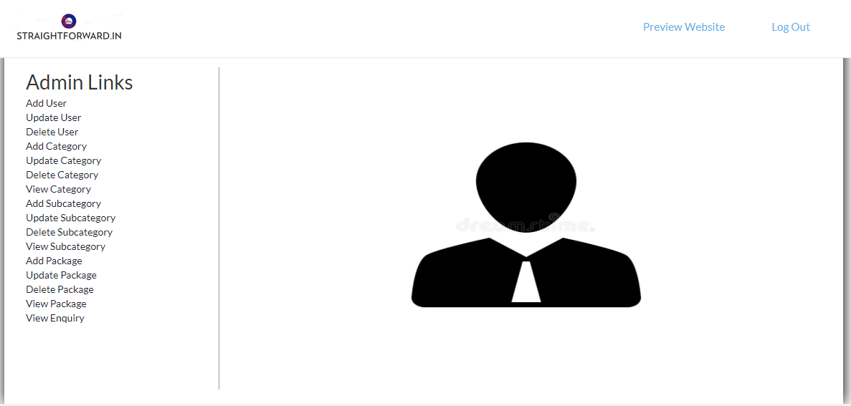

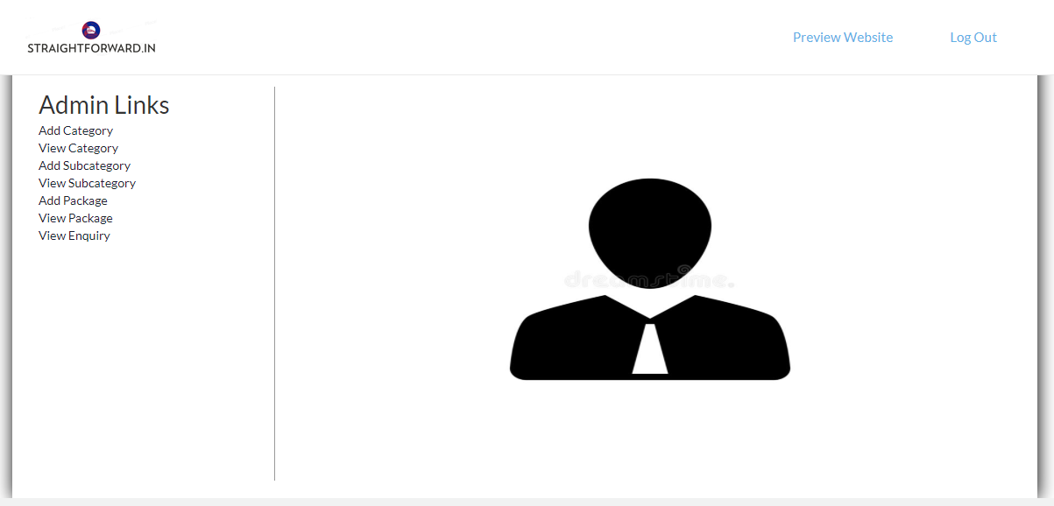

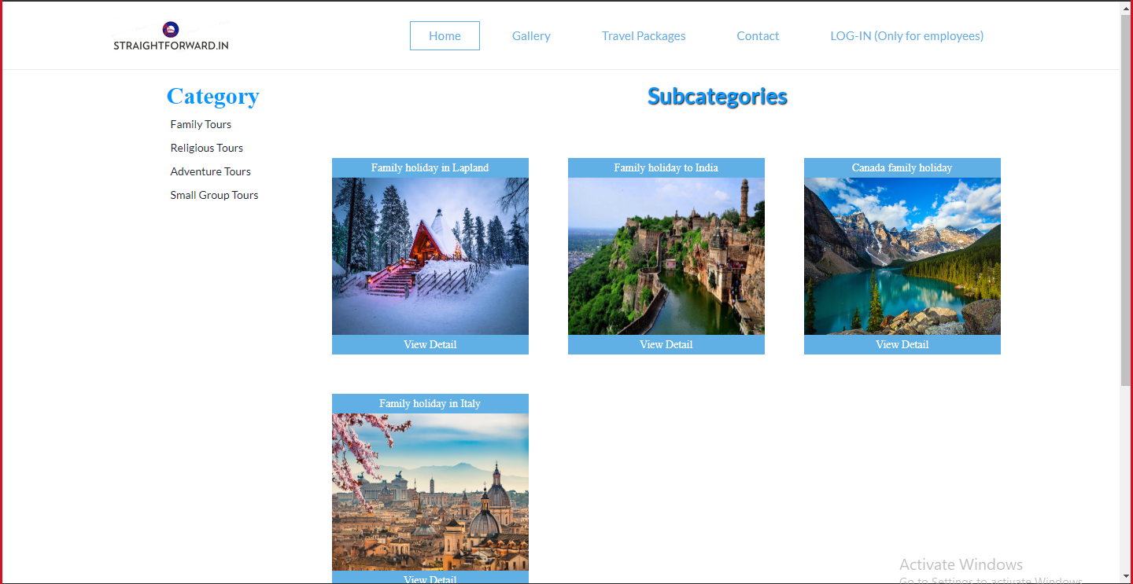

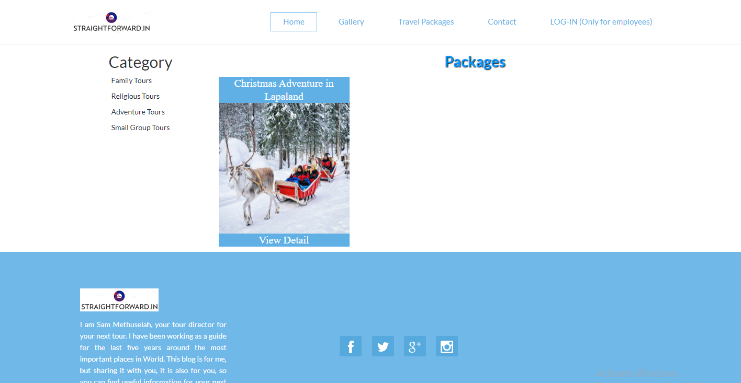

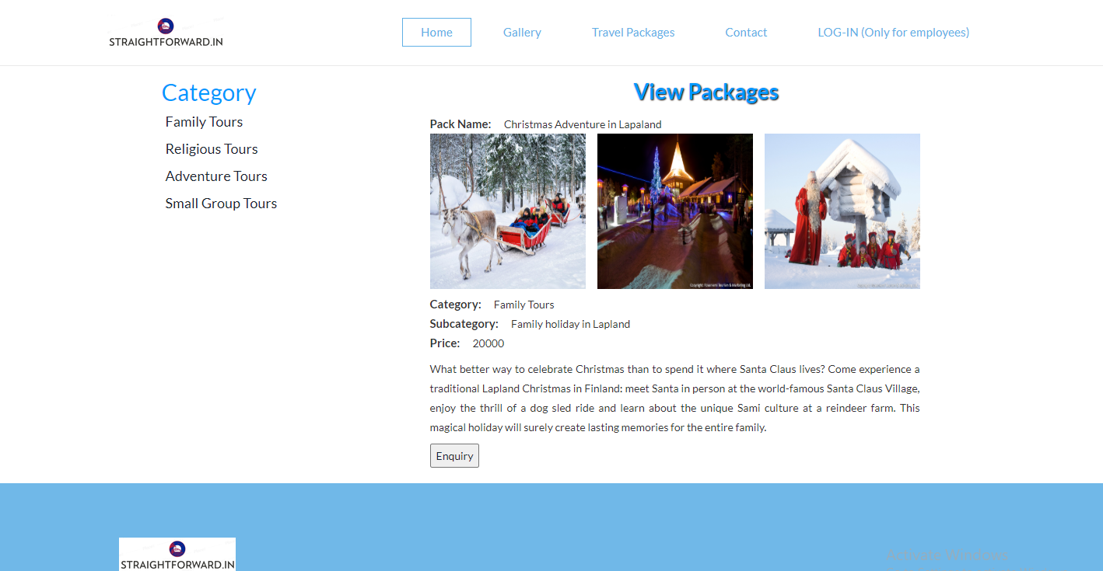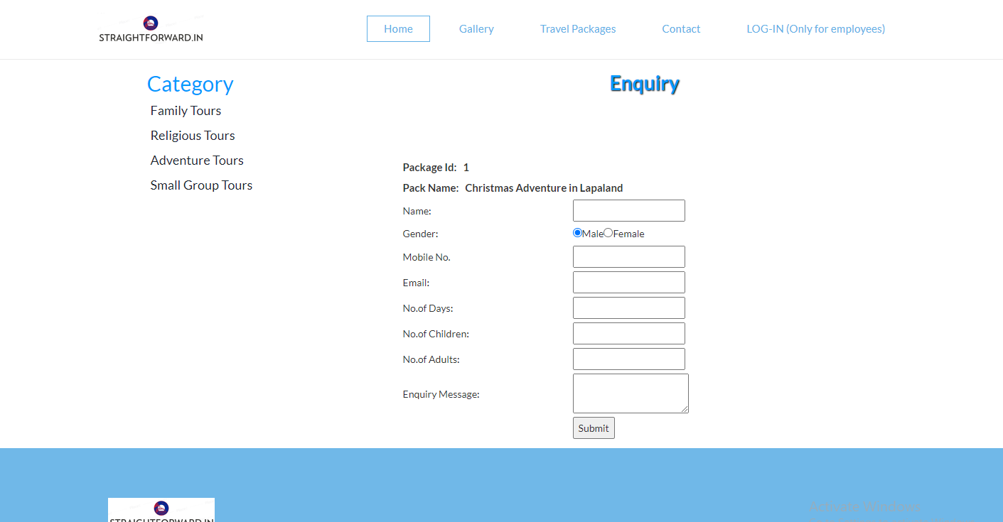

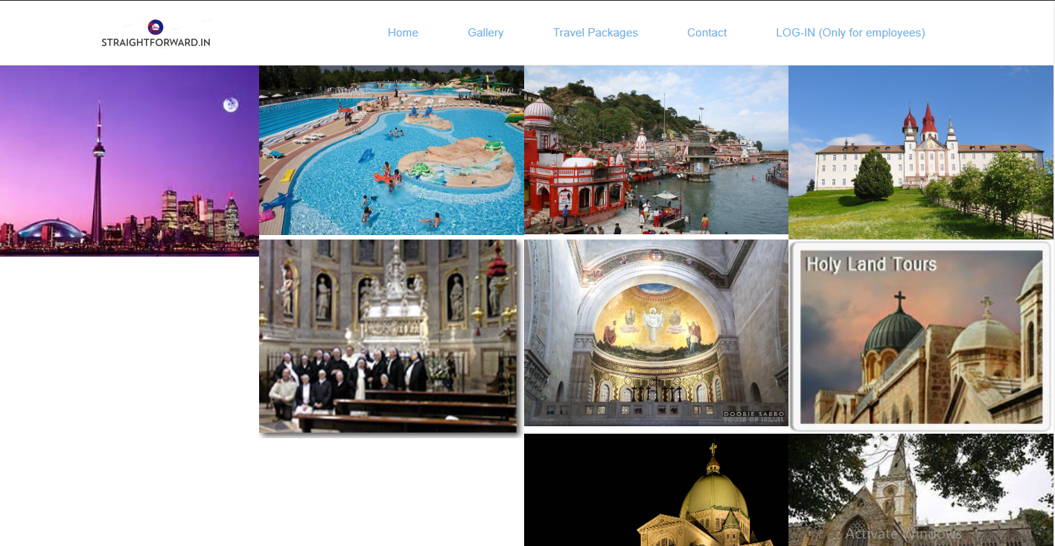

**APPENDIX: Coding and queries**

index.php

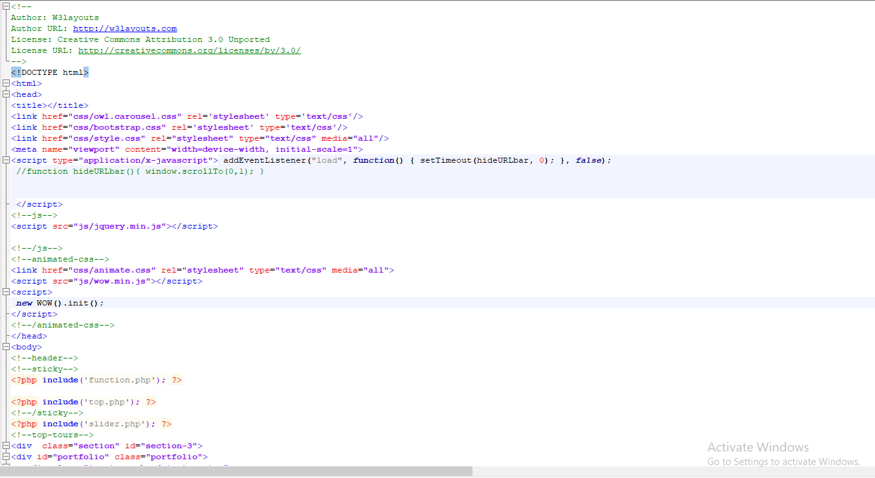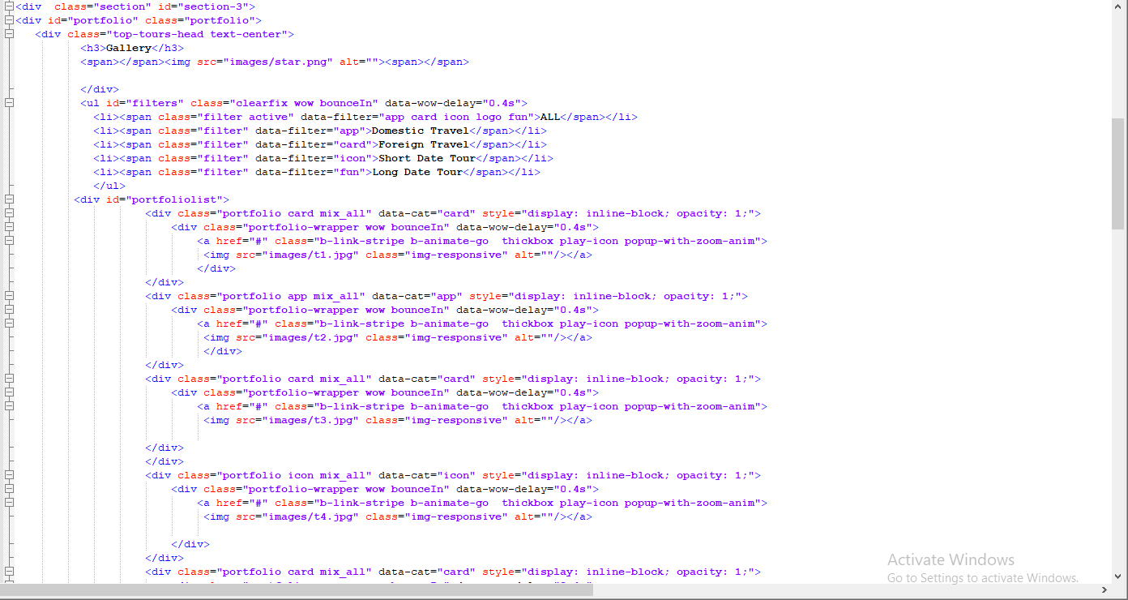

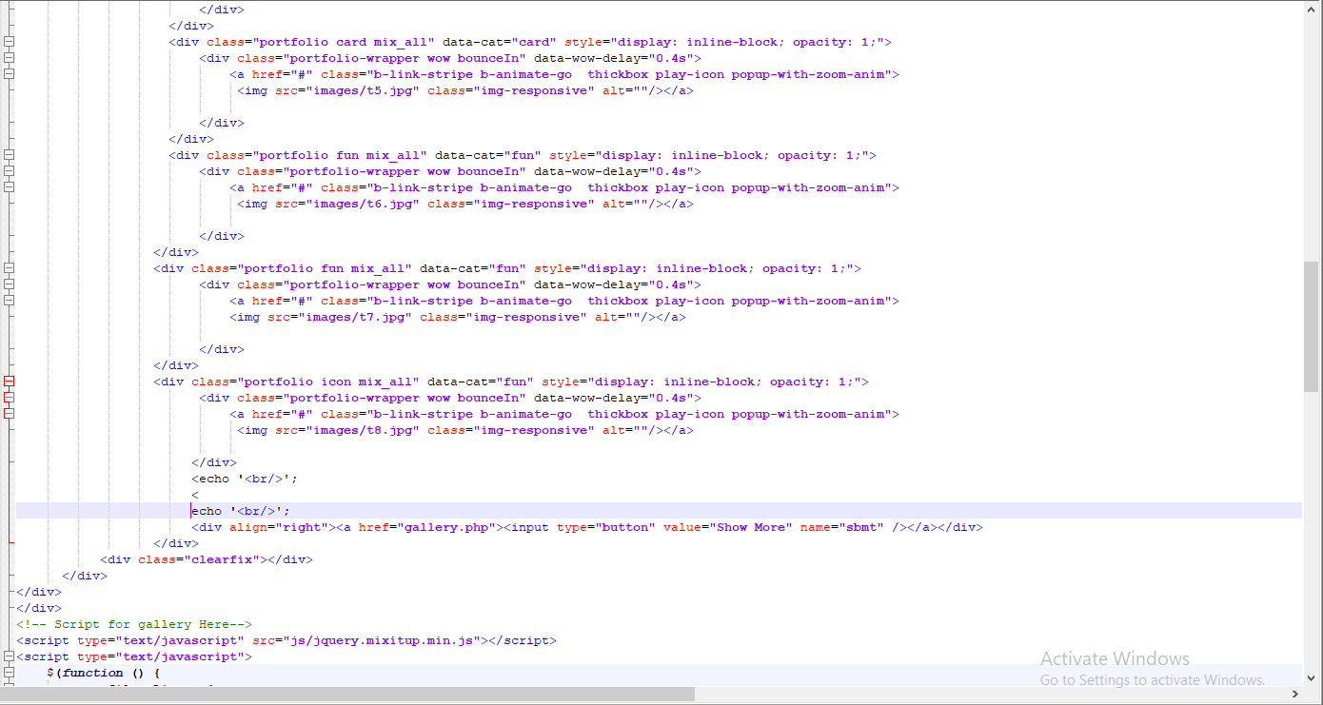

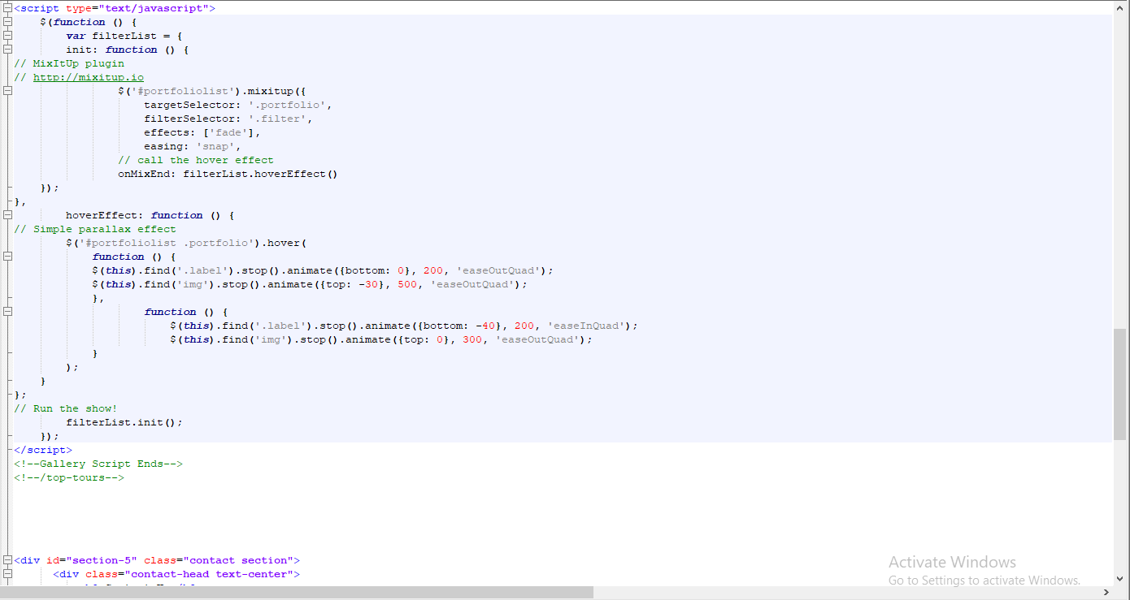

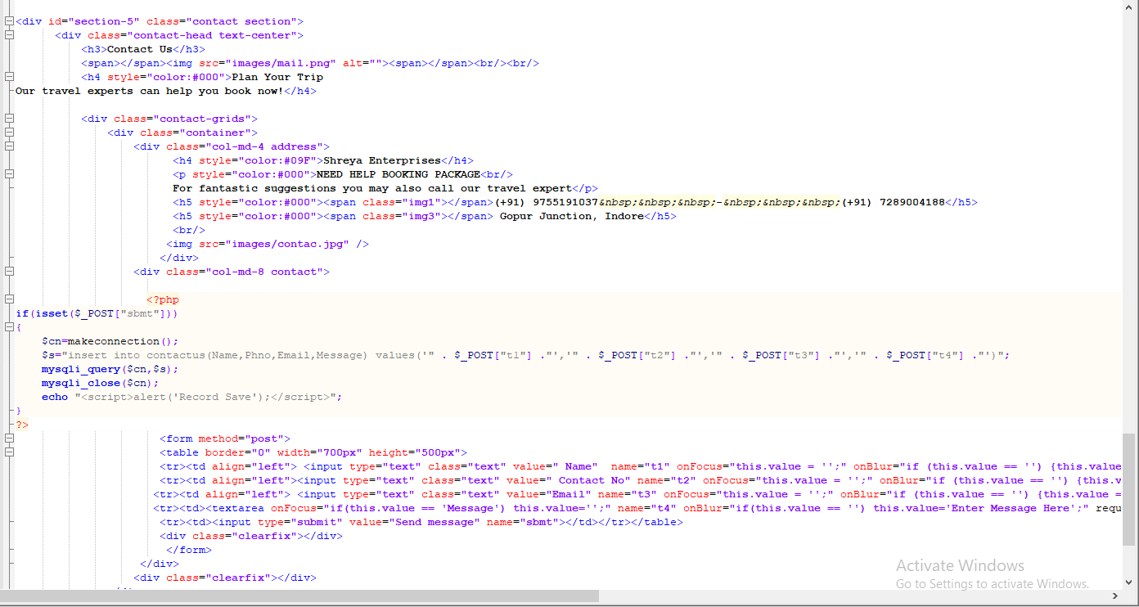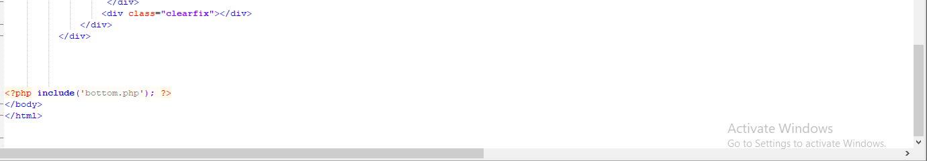

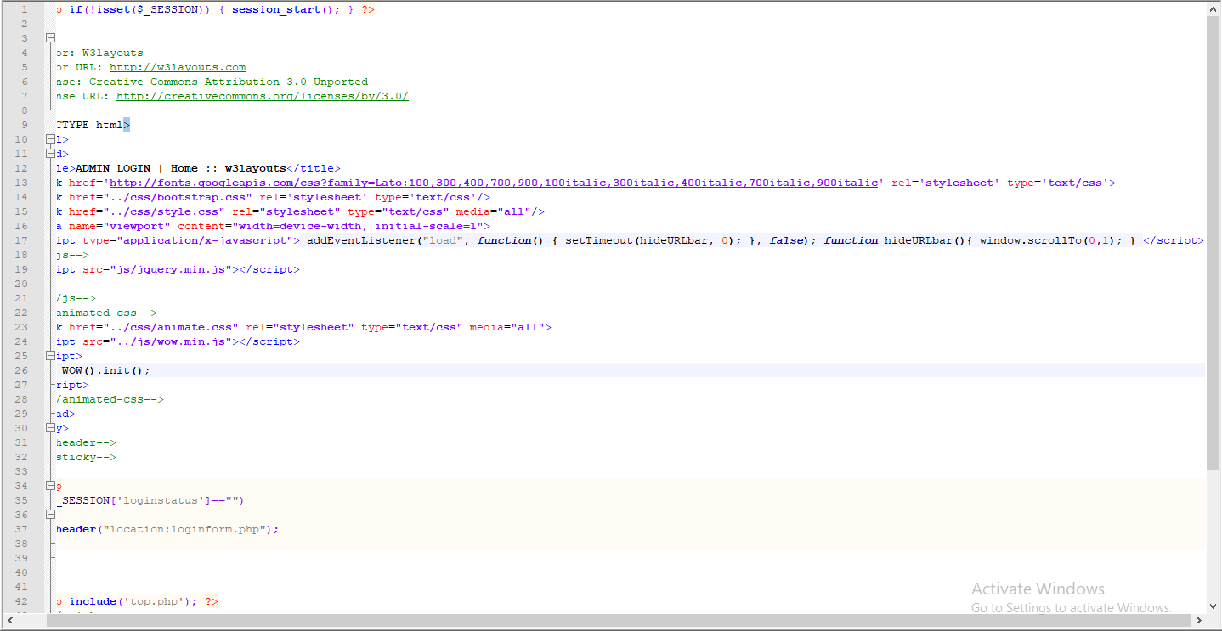**index.php of admin page:**

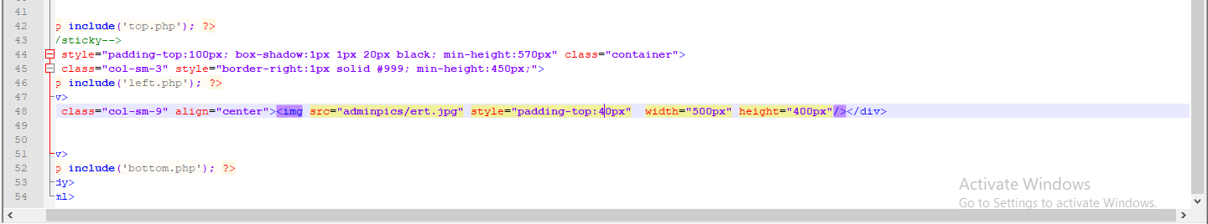

**P.T.O.->**

**Database:**

